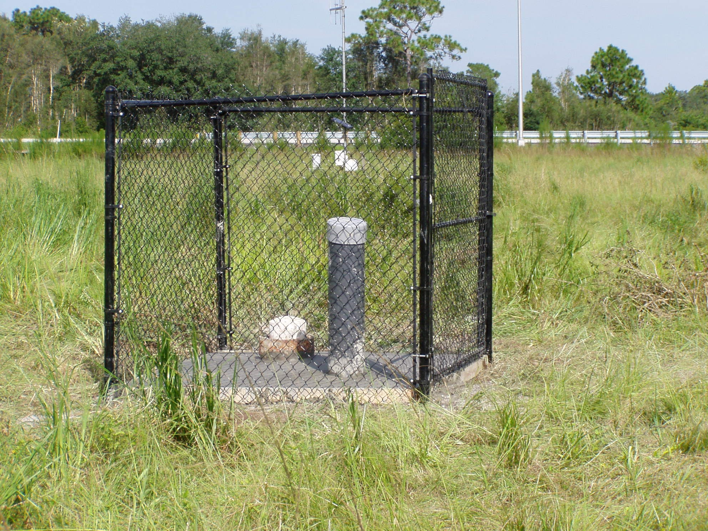
Paired Wells
OSF-60 Floridan Aquifer System Monitor well
OSS-76 Shallow Aquifer System Monitor well

