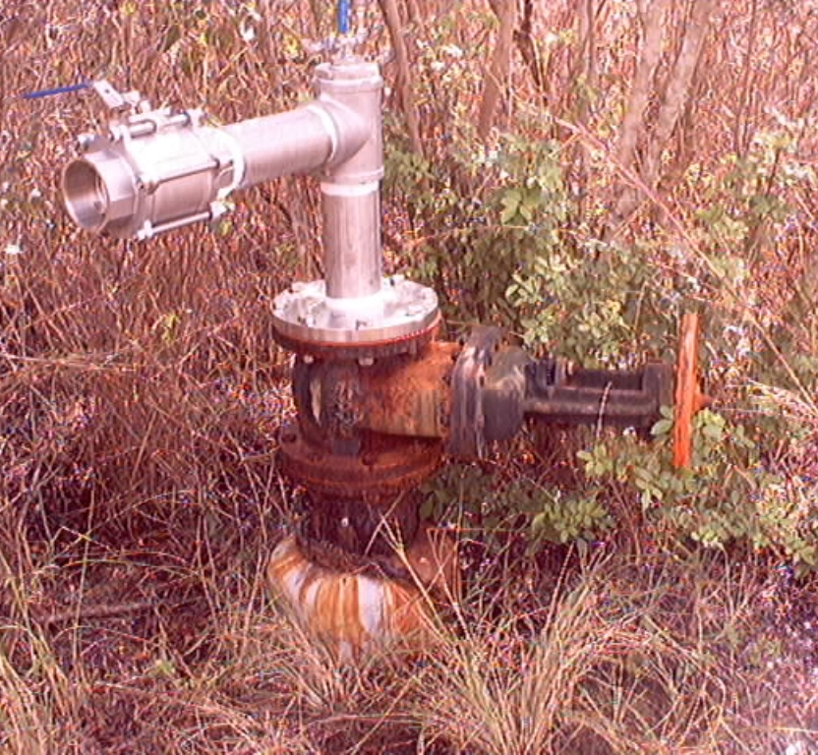

SLF-75 completed by District personnel w/no supervision (poor completion).

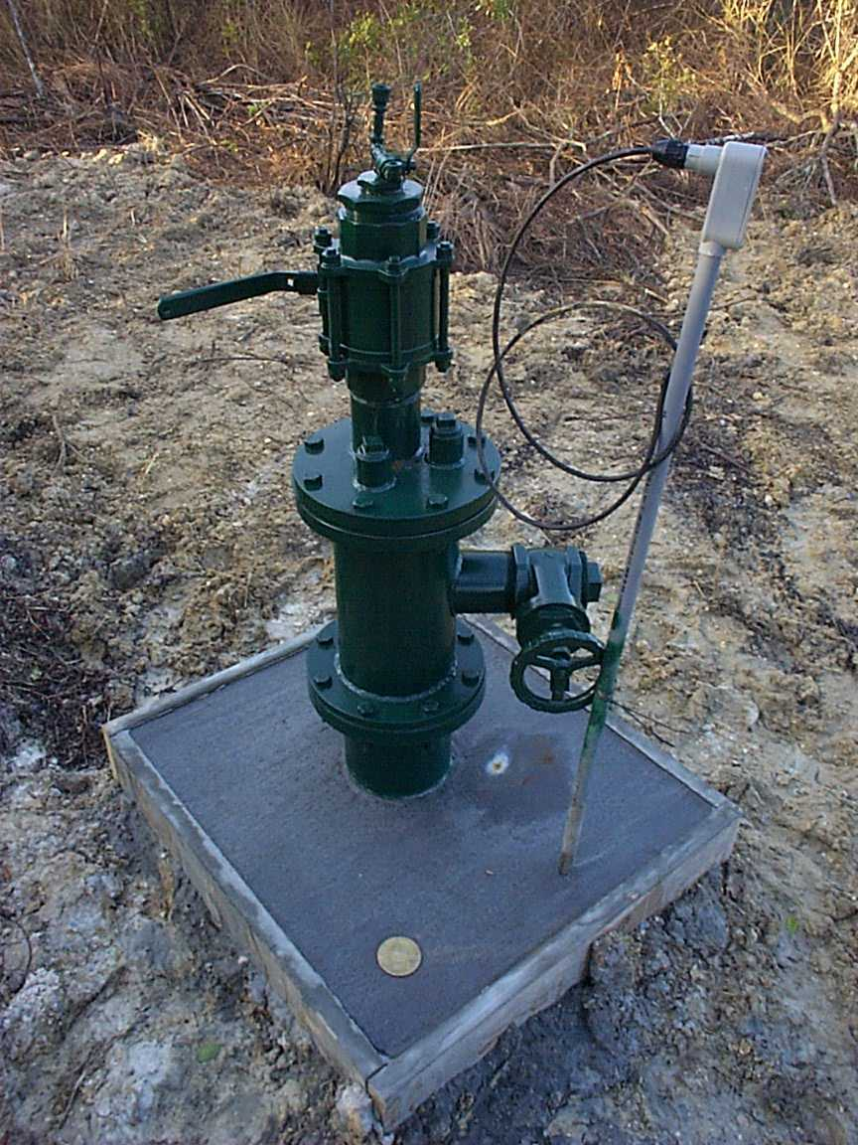

SLF-75 wellhead repair completed by contractor w/District supervision (Excellent Job!!)

