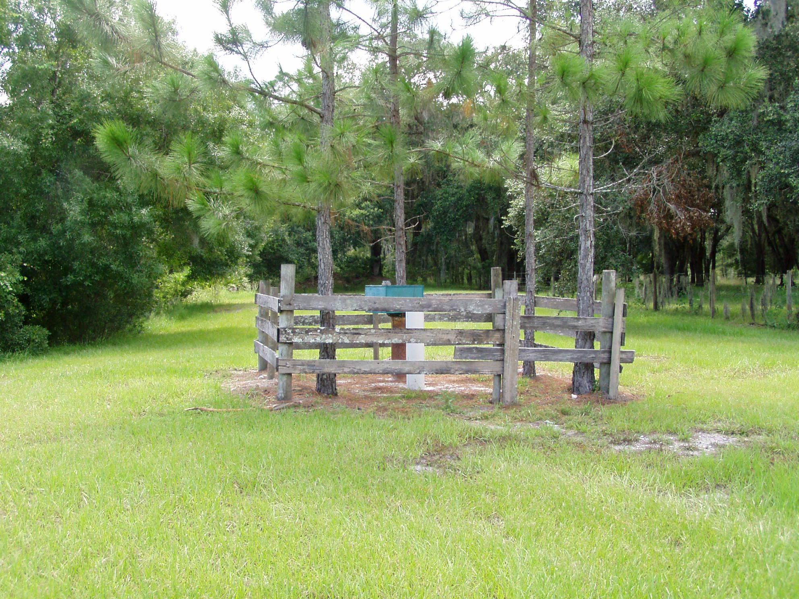

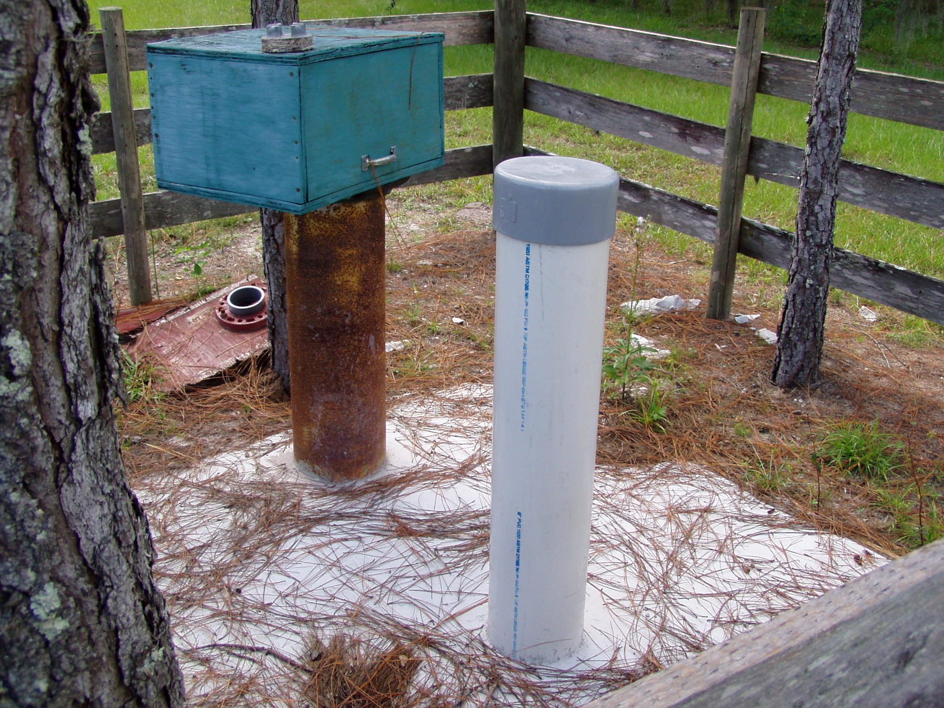

T.M. Ranch
Floridan Aquifer System Monitor well
Surficial Aquifer System Monitor well

