Site Name JDSP MW3 |  |  |  |  | Date of Field Work  6/7/10 & 10/8/15
Party Chief  Ebanks/Rodriguez | Field Book Name/Number  MISC. 6 J |  |  |  | Page Number(s)  Pg. 32
Site Benchmark Name  BM A 170 | Benchmark Elevation (NAVD88)  11.434ft |  |  |  | Datum Offset to NGVD29  +1.50
Reference Elevation (NAVD 88)  8.01ft |  |  |  | Existing Tag Elevation (Datum)  9.51ft (NGVD 29)
Latitude  26° 59’ 02” |  |  |  | Longitude  80° 06’ 11”
Notes: Datum Upgrade to NAVD 88 from NGVD 29

Photographs
Overall Site  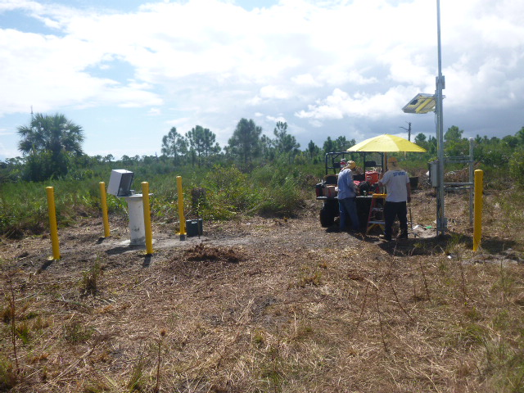 |  | Benchmark Location  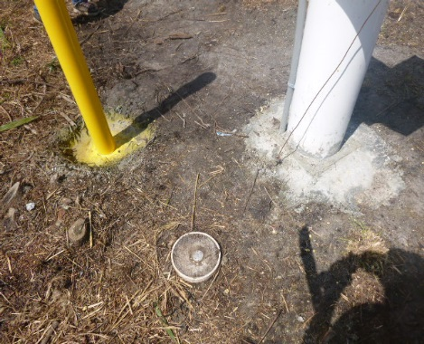 |  |  |  | Benchmark Close Up  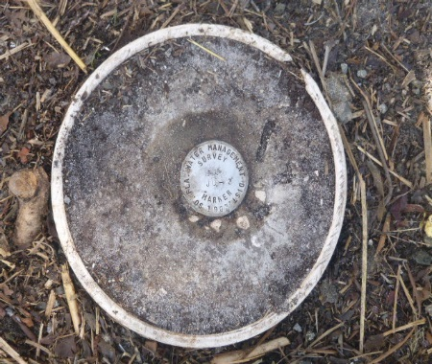
Brass Tag Close Up  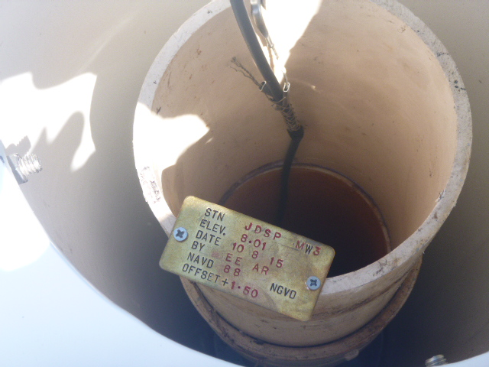 |  |  | Brass Tag + Reference Mark  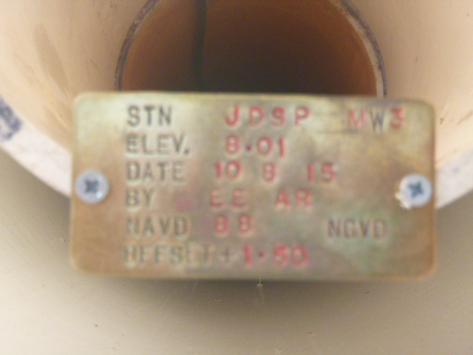
Staff Gauge (Front View) |  |  | Staff Gauge (Side View)

