Well Condition Report
RMBAKER LLC was retained by the South Florida Water Management District (SFWMD) to perform a well video of PZ5D at the L8 reservoir site.
The purpose of the well video survey was to confirm the condition of the well, well depths and construction, and identify any potential problems for well serviceability.
The well logging work was performed on February 4, 2019.

WELL ID: PZ5D
LOGGING DATE: Feb 4, 2019

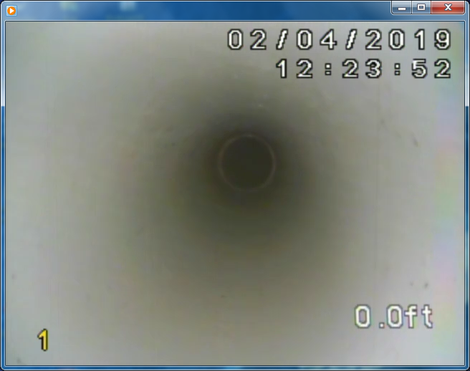 |  | 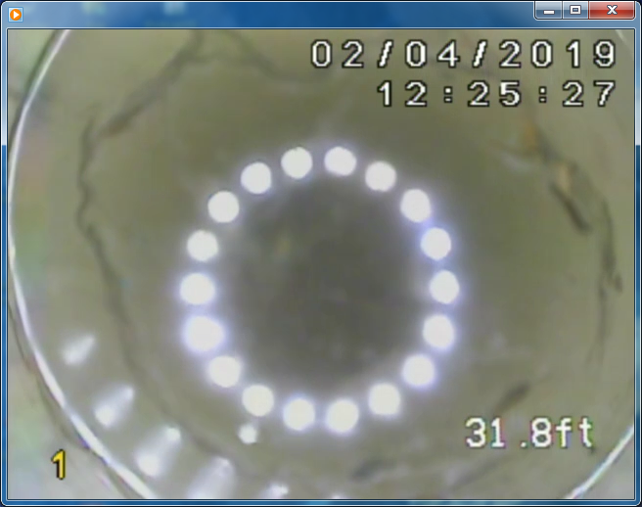
Depth: 0.0  At top of casing reference; elevation 33.29 ft NAV88. |  | Depth: 31.8  Just above water level at 31.9 ft.
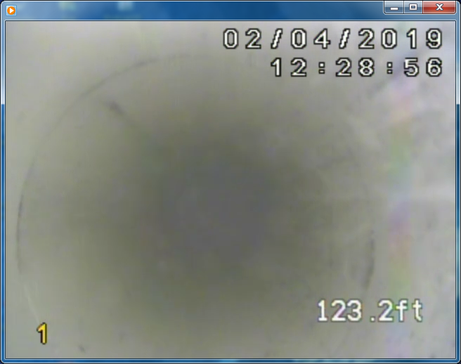 |  | 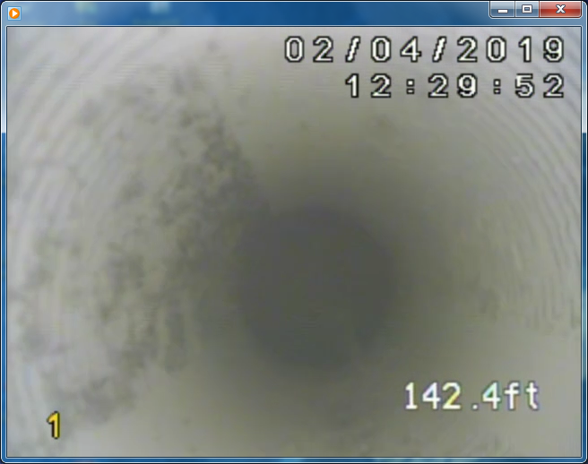
Depth: 123.2  PVC casing joint 10 ft above the presumed (but poorly visible) top of screen at 133 ft. |  | Depth: 142.4  View of screen slots just above a total depth of 143.0 ft.

Comments
- The SFWMD DBHYDRO database showed a total depth of 140 ft, with a top of screen at 130 ft.
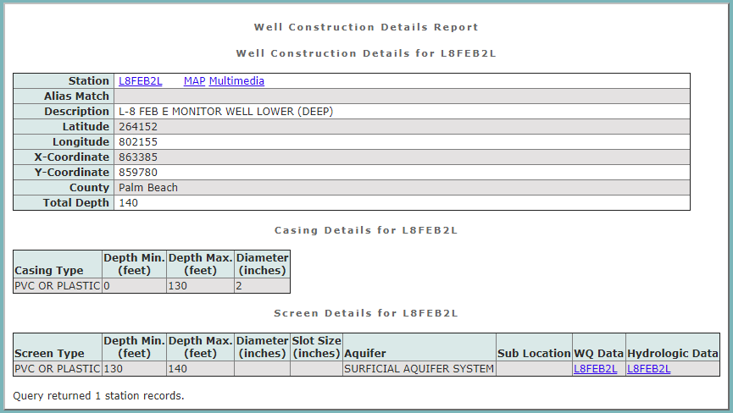
- Our video total depth was 143.0 ft and our geophysical logging total depth was 143.1 ft.
- Our original logs performed in May 2017 indicated a depth of 139.75 ft for the open borehole during well construction, and these were most likely referenced to approximate ground surface.
- The DBHydro database appeared to show depth below ground surface for well construction records.

Limitations
While due care has been exercised in the performance of these measurements and observations, in accordance with methodologies utilized by the general practitioner, RMBAKER LLC can make no representations, warranties, or guarantees with respect to latent or concealed conditions that may exist, which may be beyond the detection capabilities of the methodologies used, or that may extend beyond the area and depths surveyed. The analyses and conclusions contained in our report are based on site conditions as they existed at the time of our survey. If, at any time, different subsurface conditions from those interpreted herein are observed to be present, we reserve the right to modify our analyses and conclusions as warranted by the new information.

ELECTRONIC VERSION
SIGNED AND SEALED
HARDCOPY ON FILE

RMBAKER LLC
Robert M. Baker, CPG, PG
Managing Member
Fla. Reg. Geologist No. 2186

